***About the Hines VA Hospital***

Located 12 miles west of downtown Chicago, the Edward Hines, Jr. VA Hospital is a comprehensive health care center serving the veteran population of the greater metropolitan Chicago and northwest Indiana regions and is institutionally affiliated with the Loyola University Medical Center.

Hines offers primary, long term care, home care, and specialty care and serves as a tertiary care referral center for other VHA facilities. Specialized clinical programs include Blind Rehabilitation, Spinal Cord Injury, Neurosurgery, Radiation Therapy and Cardiovascular Surgery.

The VA currently operates ~470 hospital beds, including acute care and nursing home beds, in addition to 6 community based outpatient clinics (CBOCs) in Elgin, Kankakee, Oak Lawn, Aurora, LaSalle, and Joliet. Hines has an integrated research program encompassing HSR&D and a cooperative studies program.

**Residency Program Director**:

**Ursula C. Patel, Pharm.D., BCIDP, BCPS, AAHIVP**

**Tel: 708-202-8387, ex. 2-4526**

**E-mail:** [**ursula.patel@va.gov**](mailto:ursula.patel@va.gov)

**Chief of Pharmacy Services:**

Elizatbeth L. Stone, Pharm.D.

Email: [elizabeth.stone1@va.gov](mailto:elizabeth.stone1@va.gov)



**PGY2 Infectious Diseases Residency**

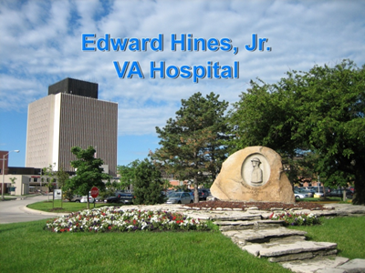

**Edward Hines, Jr. VA Hospital**

5000 S. Fifth Ave.

Hines, IL 60141

(708) 202-8387

***Hines VA PGY2 Infectious Diseases Residency***

***Purpose/Description*:**

The purpose of this PGY2 residency is to provide comprehensive learning experiences in a variety of Infectious Diseases-related areas in order to afford the resident opportunity to advance and solidify their Infectious Diseases pharmacotherapy knowledgebase. The resident will have the opportunity to be involved in the care of a variety of infectious disease states in diverse patient populations, including acute care, surgical care, medical intensive care, spinal cord injury, and long term care.

Teaching opportunities will be available for the resident with PGY1 residents as well as pharmacy students from affiliated universities, including University of Illinois Chicago College of Pharmacy and Midwestern University Chicago College of Pharmacy. Inter-professional teaching opportunities with the ID medical fellows and residents will also be integrated into this residency training.

***Learning Experiences*:**

* Orientation/Pharmacy Operations
* Microbiology Lab
* Antimicrobial Stewardship
* ID Consult Service
* Internal Medicine
* Critical Care
* Hepatology/Transplant
* Transplant Infectious Diseases
* Pharmacy Benefits Management (PBM)
* Didactic/formal lecture for Pharmacy Students

*Longitudinal experiences:*

* Research/QA/QI project
* ID/HIV outpatient clinic
* ID Pharmacy Administration
* Outpatient Parenteral Antimicrobial Therapy (OPAT)

***Residency Benefits*:**

* Competitive stipend
* 11 paid holidays, 13 vacation days, 13 sick days
* Professional travel reimbursment, when possible

***Residency Application Requirements*:**

* U.S. citizenship
* Pharm.D. with successful completion of ASHP accredited PGY1 residency
* Academic transcript
* Curriculum vitae
* Letter of intent
* Three letters of recommendation

***Please check out the Edward Hines, Jr. VA Hospital PGY2 Infectious Diseases*** ***Residency Listing on the ASHP website and/or contact the Residency Program Director for additional information.***

***You may also visit*** [***http://www.hines.va.gov/about/pharm_residency.asp***](http://www.hines.va.gov/about/pharm_residency.asp) ***to obtain more information about the facility and the residency programs.***

*\*This residency site agrees that no person at this site will solicit, accept, or use any ranking-related information from any residency applicant.*